|  |  |
| --- | --- |
| **Add Exp-2** | **Implement an application that writes data to the SD card.** |
|  |

# Aim:

To develop a Android Application that writes data to the SD Card.

# Procedure:

* Open eclipse or android studio and create new project
* Select our project in the project explorer
* Go to res folder and select layout Double click the main xml file
* Type the code for main.xml or drag and drop various components used in our program
* Drag and drop relative layout and change its properties
* Drag and drop image view and change its properties according to our programs
* Screen layout can be viewed by clicking graphics layout tab
* Include necessary files
* Override OnCreate() function
* Create Image view and initialize its using id of some components used in the xml program
* Save the program
* Run the program
* Output can be viewed in the android emulator

# Code for Activity_main.xml:

<?xml version="1.0" encoding="utf-8"?>

<LinearLayout xmlns:android[="ht](http://schemas.android.com/apk/res/android)tp[://schemas.android.com/apk/res/android](http://schemas.android.com/apk/res/android)"

android:layout_width="match_parent" android:layout_height="match_parent" android:layout_margin="20dp" android:orientation="vertical"

<EditText

android:id="@+id/editText" android:layout_width="match_parent" android:layout_height="wrap_content" android:singleLine="true" android:textSize="30dp" />

<Button

android:id="@+id/button" android:layout_width="match_parent" android:layout_height="wrap_content" android:layout_margin="10dp" android:text="Write Data" android:textSize="30dp" />

<Button

android:id="@+id/button2" android:layout_width="match_parent"

android:layout_height="wrap_content" android:layout_margin="10dp" android:text="Read data" android:textSize="30dp" />

<Button

android:id="@+id/button3" android:layout_width="match_parent" android:layout_height="wrap_content" android:layout_margin="10dp" android:text="Clear" android:textSize="30dp" />

</LinearLayout>

Code for AndroidManifest.xml:

<?xml version="1.0" encoding="utf-8"?>

<manifest xmlns:android[="ht](http://schemas.android.com/apk/res/android)tp[://schemas.android.com/apk/res/android](http://schemas.android.com/apk/res/android)"

package="com.example.exno9" >

<uses-permission android:name="android.permission.INTERNET "></uses-permission>

<application android:allowBackup="true" android:icon="@mipmap/ic_launcher" android:label="@string/app_name" android:supportsRtl="true"

android:theme="@style/AppTheme" >

<activity android:name=".MainActivity" >

<intent-filter>

<action android:name="android.intent.action.MAIN" />

<category android:name="android.intent.category.LAUNCHER" />

</intent-filter>

</activity>

</application>

</manifest>

# Code for MainActivity.java:

package com.example.exno9; import android.os.Bundle;

import android.support.v7.app.AppCompatActivity; import android.view.View;

import android.widget.Button; import android.widget.EditText; import android.widget.Toast; import java.io.BufferedReader; import java.io.File;

import java.io.FileInputStream; import java.io.FileOutputStream; import java.io.InputStreamReader;

public class MainActivity extends AppCompatActivity

{

EditText e1;

Button write,read,clear; @Override

protected void onCreate(Bundle savedInstanceState){ super.onCreate(savedInstanceState); setContentView(R.layout.activity_main);

e1= (EditText) findViewById(R.id.editText); write= (Button) findViewById(R.id.button); read= (Button) findViewById(R.id.button2); clear= (Button) findViewById(R.id.button3);

write.setOnClickListener(new View.OnClickListener()

{@Override

public void onClick(View v)

{

String message=e1.getText().toString(); try{

File f=new File("/sdcard/myfile.txt"); f.createNewFile();

FileOutputStream fout=new FileOutputStream(f); fout.write(message.getBytes());

fout.close();

Toast.makeText(getBaseContext(),"Data Written in SDCARD",Toast.LENGTH_LONG).show();

}

catch (Exception e)

{

Toast.makeText(getBaseContext(),e.getMessage(),Toast.

LENGTH_LONG).show();

}

}

});

read.setOnClickListener(new View.OnClickListener()

{

@Override

public void onClick(View v)

{

String message; String buf = ""; try

{

File f = new File("/sdcard/myfile.txt");

FileInputStream fin = new FileInputStream(f); BufferedReader br = new BufferedReader(new

InputStreamReader(fin));

while ((message = br.readLine()) != null)

{

buf += message;

}

e1.setText(buf); br.close();

fin.close();

Toast.makeText(getBaseContext(),"Data Recived from SDCARD",Toast.LENGTH_LONG).show();

}

catch (Exception e)

{

Toast.makeText(getBaseContext(), e.getMessage(), Toast.LENGTH_LONG).show();

}

} });

clear.setOnClickListener(new View.OnClickListener() { @Override

public void onClick(View v{ e1.setText(""); }

});

}}

# Output:

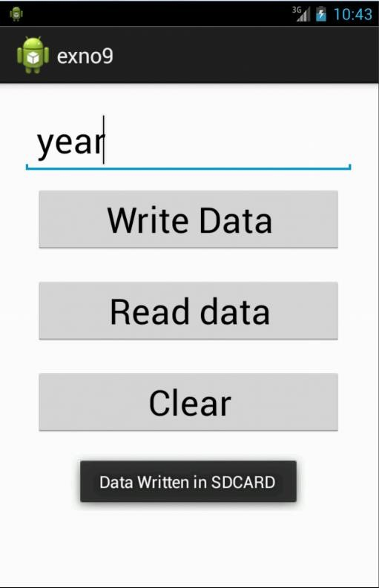

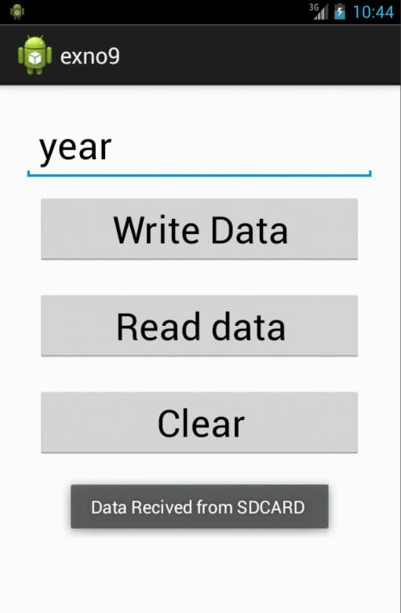

**Result:**

Thus, Android Application that writes data to the SD Card is developed and executed successfully.